Name: Lujain Zia
Roll no: 2023-BSE-034
Date: December 12, 2025

Lab 11
Task 0 Lab Setup (Codespace & GH CLI)
All actions below should be executed inside the Codespace shell.
Create Codespace & connect:
# create or open codespace via GH CLI (example)
gh repo create CC_<YourName>_<YourRollNumber>/Lab11 --public
gh codespace create --repo <user_name>/Lab11
gh codespace list
gh codespace ssh -c <your_codespace_name>
Save screenshot as: taskA_codespace_create_and_list.png — output showing repo creation/codespace list.
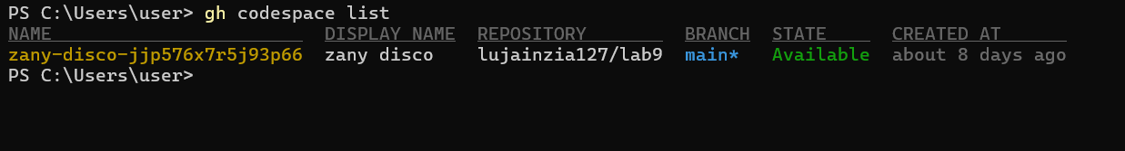
Save screenshot as: taskA_codespace_ssh_connected.png — terminal inside the Codespace shell after ssh.
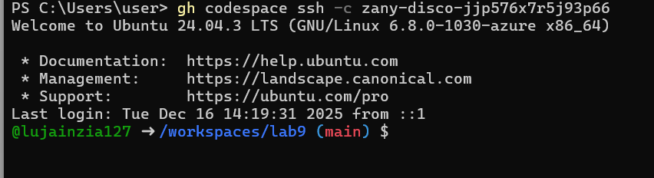

Task 1 — Provider & Basic variable (variable precedence)

- In Codespace create main.tf:
touch main.tf
Save screenshot as: task1_touch_main_tf.png — terminal showing touch main.tf.
- Edit main.tf and add provider:
provider "aws" {
shared_config_files = ["~/.aws/config"]
shared_credentials_files = ["~/.aws/credentials"]
}
Save screenshot as: task1_main_tf_provider.png — editor showing provider block saved in main.tf.
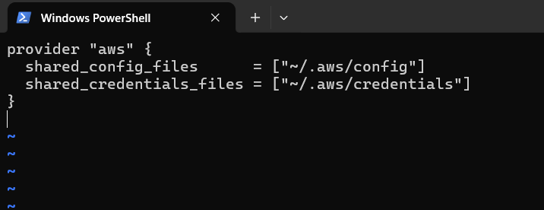
- Initialize:
terraform init
Save screenshot as: task1_terraform_init.png — terraform init output.
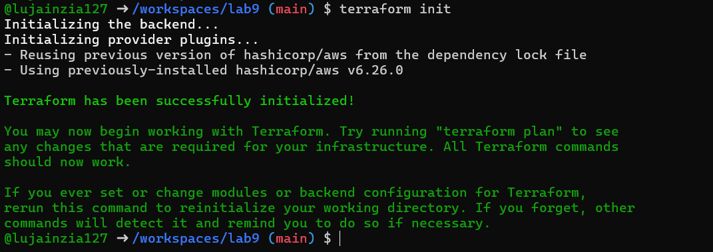
- Define a variable and output:
variable "subnet_cidr_block" {
type = string
}
output "subnet_cidr_block_output" {
value = var.subnet_cidr_block
}
Save screenshot as: task1_variable_and_output_added.png — main.tf showing variable and output blocks.
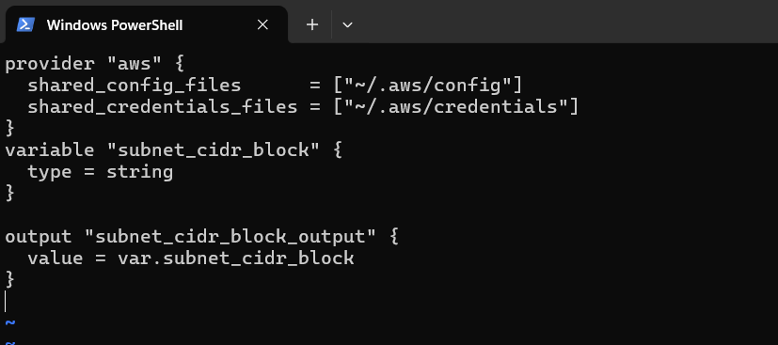
- Run apply (first time without defaults):
terraform apply -auto-approve# it will prompt for the value of subnet_cidr_block
Save screenshot as: task1_apply_prompt_for_var.png — terminal showing terraform prompting for variable input.
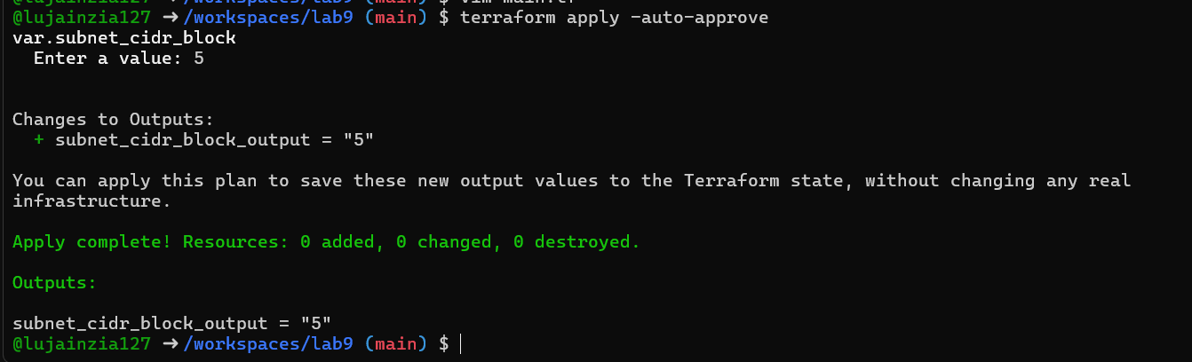
- Add a default to the variable:
variable "subnet_cidr_block" {
type = string
default = "10.0.0.0/24"
}
Run:
terraform apply -auto-approve# will use default without prompting
Save screenshot as: task1_apply_with_default.png — apply output showing default used.
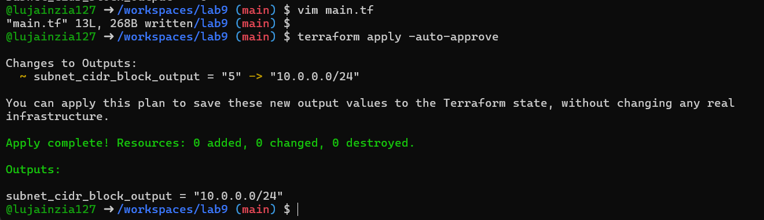
- Export environment variable in Codespace shell:
export TF_VAR_subnet_cidr_block=10.0.20.0/24
terraform apply -auto-approve# output should show environment value
Save screenshot as: task1_env_var_set_and_apply.png — terminal showing export and apply using TF_VAR value.
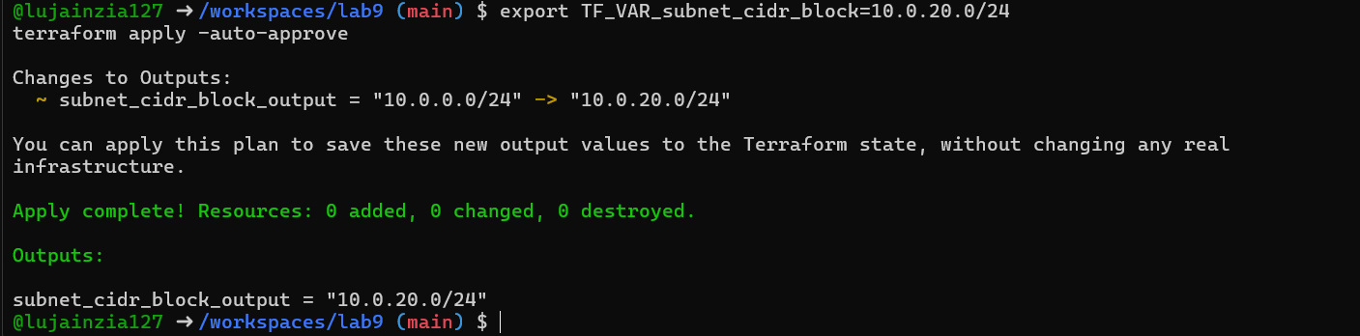
- Create terraform.tfvars overriding values:
touch terraform.tfvars# inside terraform.tfvars:
subnet_cidr_block = "10.0.30.0/24"
terraform apply -auto-approve# terraform.tfvars has priority over default and env
Save screenshot as: task1_terraform_tfvars_and_apply.png — cat terraform.tfvars and apply output showing its value used.
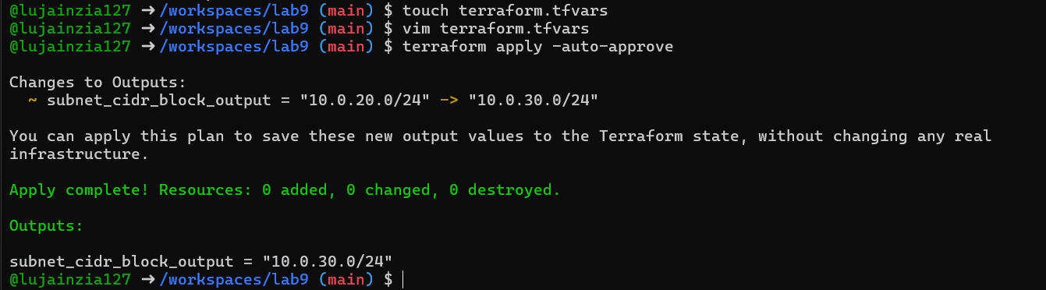
- Override with -var:
terraform apply -auto-approve -var "subnet_cidr_block=10.0.40.0/24"# -var is highest precedence
Save screenshot as: task1_var_override_with_dash_var.png — command and apply showing -var value used.
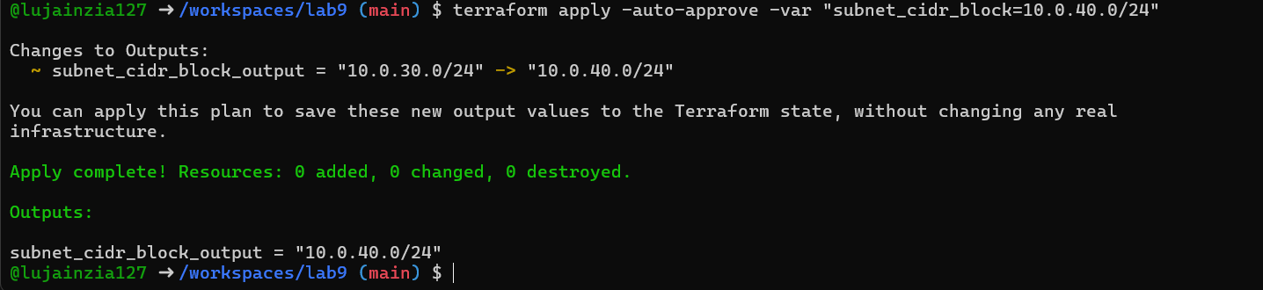
- Show and unset env var:
printenv | grep TF_VAR_unset TF_VAR_subnet_cidr_block
printenv | grep TF_VAR_
Save screenshot as: task1_printenv_tf_var_and_unset.png — showing TF_VAR present and then removed.
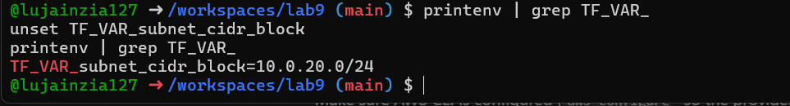

Task 2 — Variable validation & sensitive / ephemeral variables

- Replace subnet_cidr_block variable with this (validation included):
variable "subnet_cidr_block" {
type = string
default = ""
description = "CIDR block to assign to the application subnet"
sensitive = false
nullable = false
ephemeral = false

validation {
condition = can(regex("^([0-9]{1,3}\\.){3}[0-9]{1,3}/[0-9]+$", var.subnet_cidr_block))
error_message = "The subnet_cidr_block must be a valid CIDR notation string, such as 10.0.0.0/24."
}
}
Save screenshot as: task2_subnet_variable_with_validation.png — main.tf showing validation block.
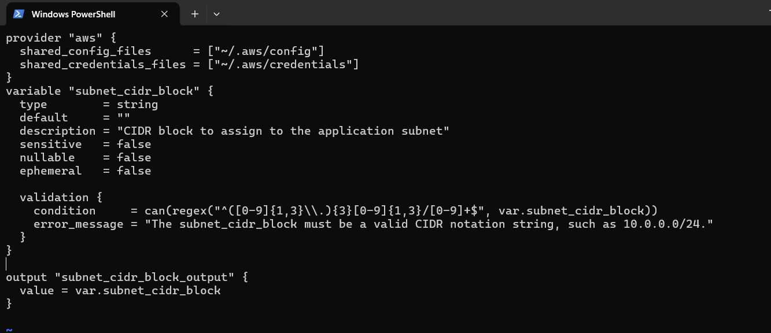
- Test validation failure:
terraform apply -auto-approve -var "subnet_cidr_block=10.0.0"# should show validation error
Save screenshot as: task2_subnet_validation_error.png — terminal showing validation error message.
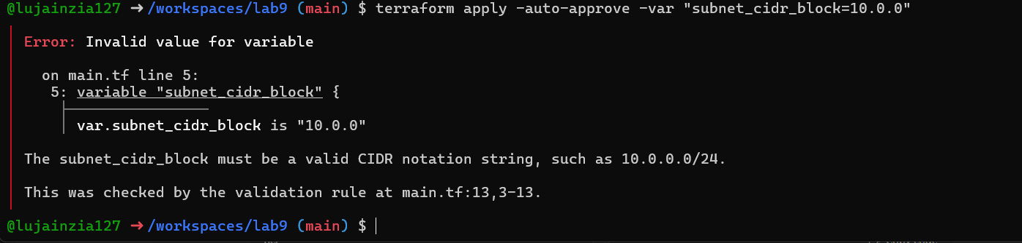
- Create a sensitive variable api_session_token and output (sensitive):
variable "api_session_token" {
type = string
default = ""
description = "Short-lived API session token used during apply operations"
sensitive = true
nullable = false
ephemeral = false

validation {
condition = can(regex("^[A-Za-z0-9-_]{20,}$", var.api_session_token))
error_message = "The API session token must be at least 20 characters and contain only letters, numbers, hyphens, or underscores."
}
}
output "api_session_token_output" {
value = var.api_session_token
sensitive = true
}
Save screenshot as: task2_api_token_variable_added.png — main.tf showing api_session_token and sensitive output.
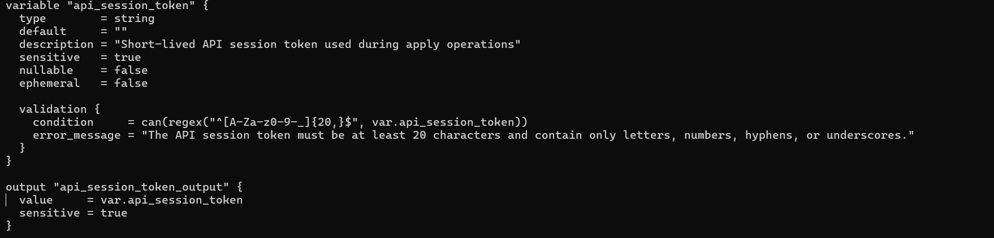
- Run with -var to observe sensitive output behavior:
terraform apply -auto-approve -var "api_session_token=my_API_session_Token"# output will be marked sensitive; check terraform.tfstate for outputs
Save screenshot as: task2_api_token_apply_sensitive.png — apply output showing sensitive output masked and/or noted.
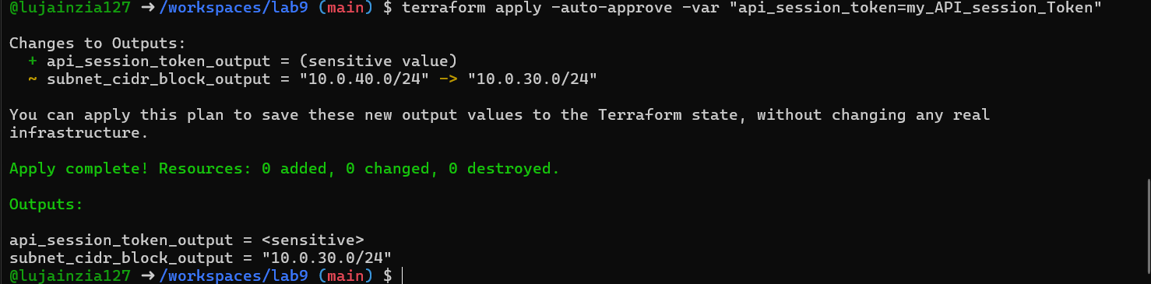
- Check terraform.state for the sensitive output:
You should find an outputs section similar to:
"api_session_token_output": {
"value": "my_API_session_Token",
"type": "string",
"sensitive": true
}
Save screenshot as: task2_check_terraform_state_api_token.png — showing terraform.tfstate outputs containing
"api_session_token_output" with sensitive = true.
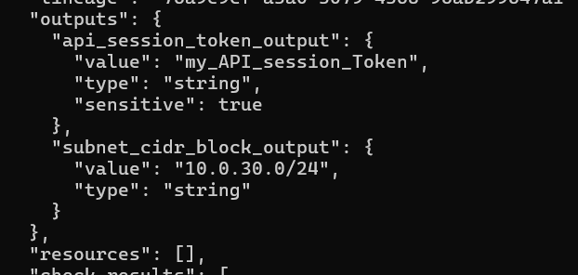
- Make variable ephemeral to hide from state:
variable "api_session_token" {
...
ephemeral = true
...
}
Save screenshot as: task2_api_token_ephemeral_error.png — terminal showing error or behavior when trying to output ephemeral variable.
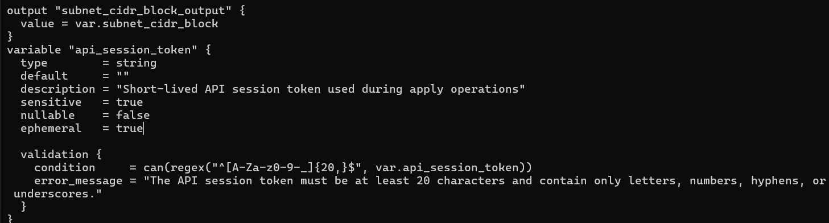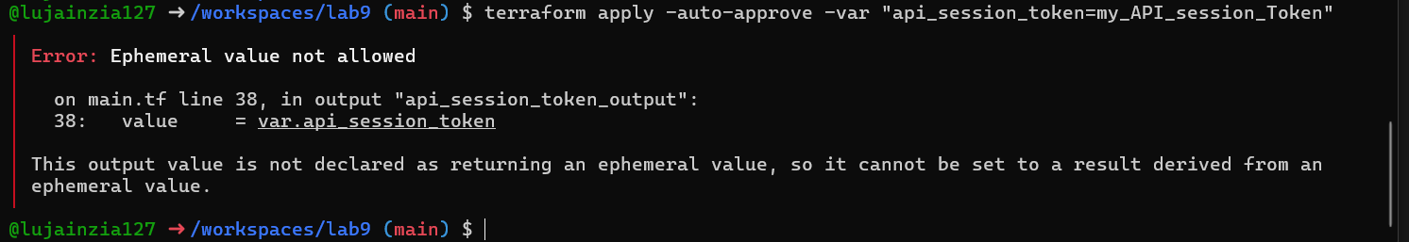
- Set default to test local default:
variable "api_session_token" {
default = "my_API_session_Token"
sensitive = true
ephemeral = false
...
}
terraform apply -auto-approve# works and stored in state (but output remains sensitive)
Save screenshot as: task2_api_token_default_apply.png — apply output showing default sensitive value accepted.
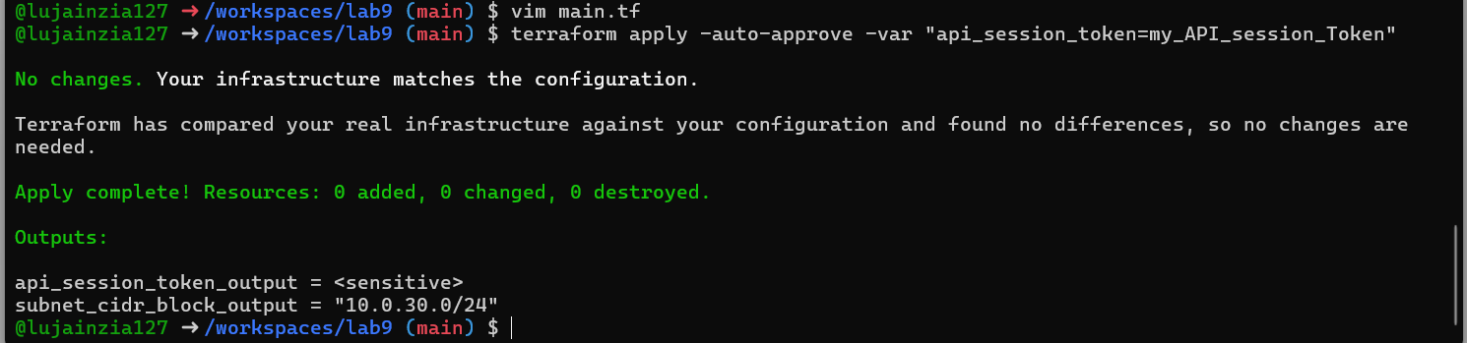

Task 3 — Project-level variables, locals, and outputs

- Add variables to main.tf:
variable "environment" {}variable "project_name" {}variable "primary_subnet_id" {}variable "subnet_count" {}variable "monitoring" {}
Save screenshot as: task3_variables_added.png — main.tf showing new variables.
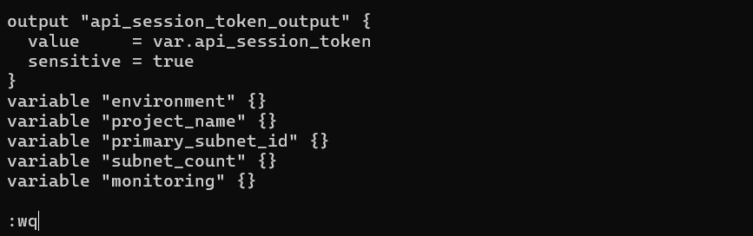
- Populate terraform.tfvars after discovering actual subnet id for availability zone me-central-1a:
aws ec2 describe-subnets \
--filters "Name=availability-zone,Values=me-central-1a" \
--query "Subnets[].SubnetId" \
--output text
Set values in terraform.tfvars:
environment = "dev"project_name = "lab_work"primary_subnet_id = "<subnet-id-of-me-central-1a>"subnet_count = 3monitoring = true
Save screenshot as: task3_terraform_tfvars_populated.png — terraform.tfvars content and aws describe-subnets output showing subnet id.
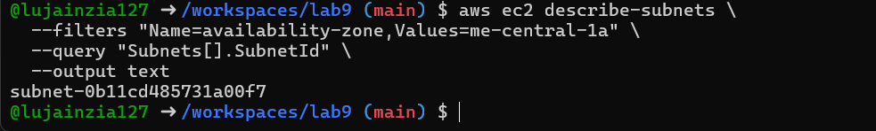
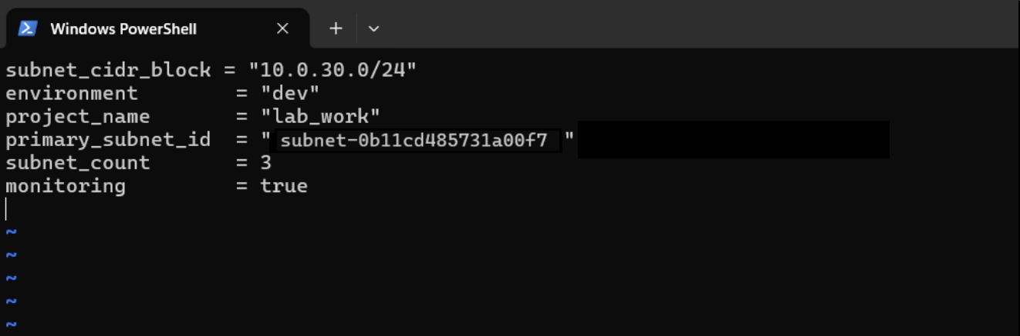

- Create locals.tf with:
locals {
resource_name = "${var.project_name}-${var.environment}"
primary_public_subnet = var.primary_subnet_id
subnet_count = var.subnet_count
is_production = var.environment == "prod"
monitoring_enabled = var.monitoring || local.is_production
}
Save screenshot as: task3_locals_tf_created.png — locals.tf content saved.
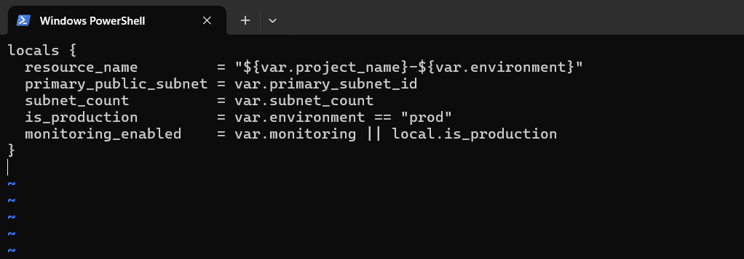
- Add outputs to main.tf:
output "resource_name" {
value = local.resource_name
}output "primary_public_subnet" {
value = local.primary_public_subnet
}output "subnet_count" {
value = local.subnet_count
}output "is_production" {
value = local.is_production
}output "monitoring_enabled" {
value = local.monitoring_enabled
}
Run:
terraform apply -auto-approve# will show all the output values
Save screenshot as: task3_outputs_apply.png — terraform apply output showing these outputs.

Task 4 — Maps and Objects

- Map variable in main.tf:
variable "tags" {
type = map(string)
}
output "tags" {
value = var.tags
}
Save screenshot as: task4_tags_variable_added.png — main.tf showing tags variable and output.
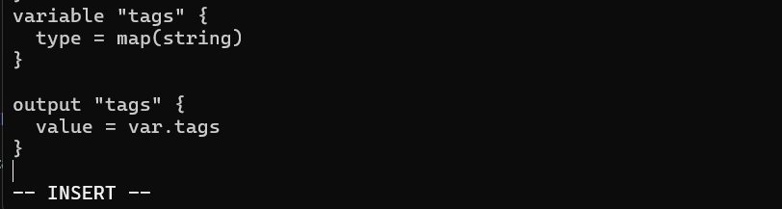
- In terraform.tfvars:
tags = {
Environment = "dev"
Project = "sample-app"
Owner = "platform-team"
}
Run:
terraform apply -auto-approve# check tags output
Save screenshot as: task4_tags_output.png — apply output showing tags returned.
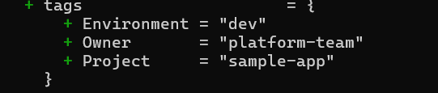
- Define object variable:
variable "server_config" {
type = object({
name = string
instance_type = string
monitoring = bool
storage_gb = number
backup_enabled = bool
})
}
output "server_config" {
value = var.server_config
}
In terraform.tfvars:
server_config = {
name = "web-server"
instance_type = "t3.micro"
monitoring = true
storage_gb = 20
backup_enabled = false
}
Save screenshot as: task4_server_config_output.png — apply output showing server_config object.
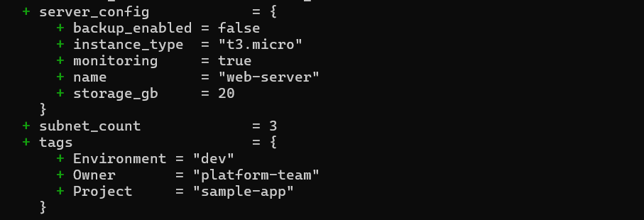
Task 5 — Collections: list, tuple, set & mutation via locals

In this task you will define collection variables (list, tuple, set), observe their behavior, then perform mutations via locals and compare results.
Feature | List | Tuple | Set
Order preserved | ✅ | ✅ | ❌
Allows duplicates | ✅ | ✅ | ❌
Mixed types | ❌ | ✅ | ❌
Fixed size | ❌ | ✅ | ❌
Mutable | ✅ | ❌ | ✅
Best for | Flexible sequences | Structured records | Unique collections
- In main.tf define:
variable "server_names" {
type = list(string)
default = ["web-2", "web-1", "web-2"]
}
variable "server_metadata" {
type = tuple([string, number, bool])
default = ["web-1", 4, true]
}
variable "availability_zones" {
type = set(string)
default = ["me-central-1b", "me-central-1a", "me-central-1b"]
}
output "compare_collections" {
value = {
list_example = var.server_names
tuple_example = var.server_metadata
set_example = var.availability_zones
}
}
Save screenshot as: task5_collections_defined.png — main.tf showing collection variables and output.
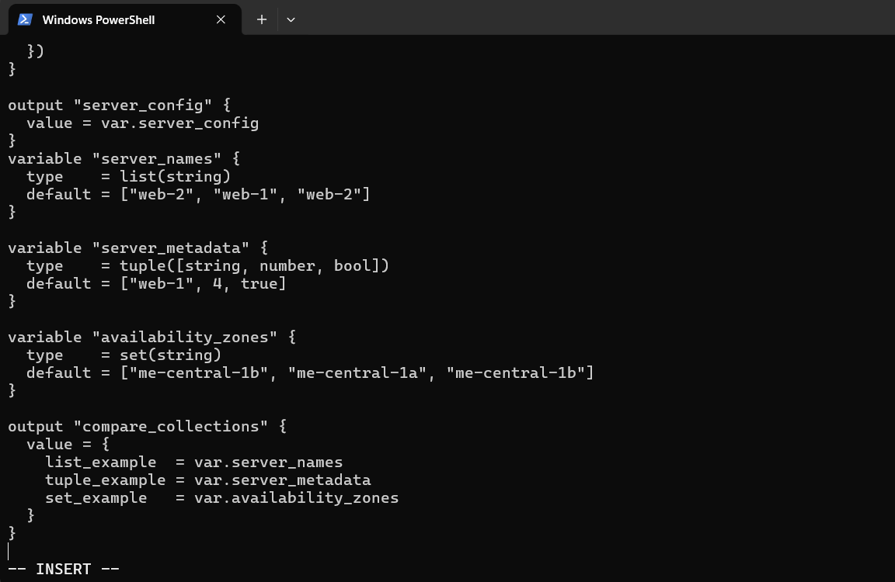
- Run:
terraform apply -auto-approve
Observe the output — note ordering, duplicates, and that sets are displayed without duplicates and order is not guaranteed.
Save screenshot as: task5_compare_collections.png — apply output comparing of collections.
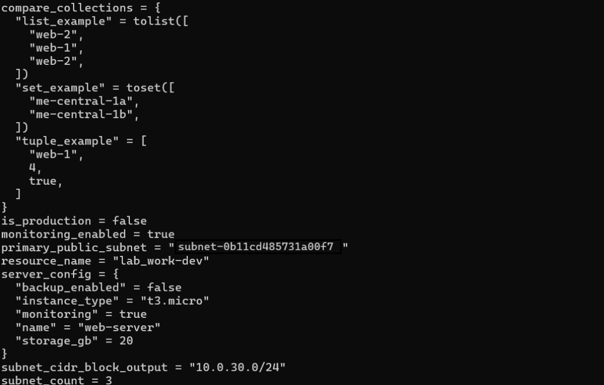
- In locals.tf add mutations: Create or edit locals.tf and add the following locals to demonstrate mutation behavior. Note: tuples are immutable in Terraform's type system, but many operations convert them to lists for evaluation.
locals {
mutated_list = setunion(var.server_names, ["web-3"])
mutated_tuple = setunion(var.server_metadata, ["web-2"])
mutated_set = setunion(var.availability_zones, ["me-central-1c"])
}
Save screenshot as: task5_locals_mutations.png — locals.tf showing mutated values.
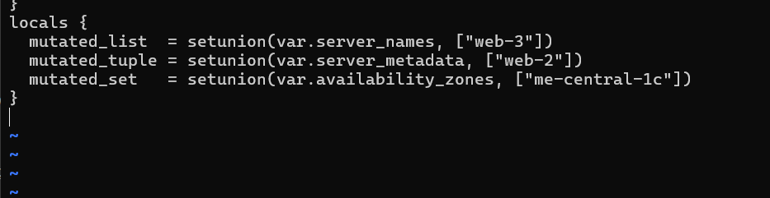
- Add comparison output in main.tf:
output "mutation_comparison" {
value = {
original_tuple = var.server_metadata
mutated_tuple = local.mutated_tuple
}
}
Run:
terraform apply -auto-approve
Observe the difference between the original tuple and the mutated result. Note that Terraform may represent the mutated tuple as a list and the ordering/duplicates behavior will reflect setunion semantics.
Save screenshot as: task5_mutation_comparison.png — apply output comparing original and mutated tuple.
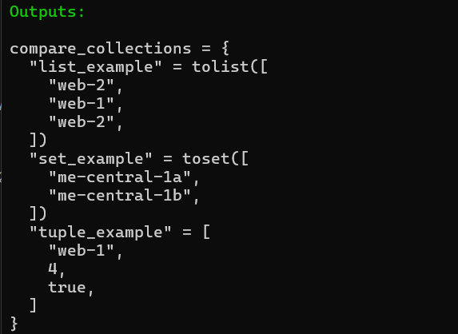
Task 6 — Null, any type & dynamic values

- Null variable:
variable "optional_tag" {
type = string
description = "A tag that may or may not be provided"
default = null
}
Save screenshot as: task6_optional_tag_variable.png — main.tf showing optional_tag variable.
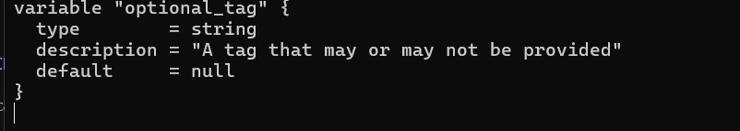
- Merge tags in locals.tf:
locals {
server_tags = merge(
{ Name = "web-server" },
var.optional_tag != null ? { Custom = var.optional_tag } : {}
)
}
Save screenshot as: task6_locals_merge.png — locals.tf showing merge logic.
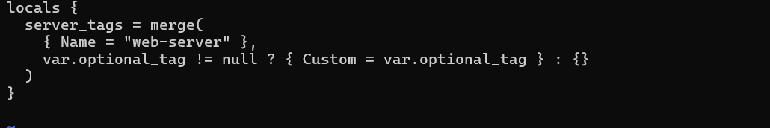
- Output:
output "optional_tag" {
value = local.server_tags
}
Run:
terraform apply -auto-approve
Save screenshot as: task6_optional_tag_no_value.png — apply output with no optional_tag set.
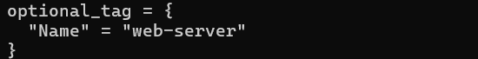
- Add in terraform.tfvars:
optional_tag = "dev"
terraform apply -auto-approve# observe that Custom tag appears
Save screenshot as: task6_optional_tag_with_value.png — apply output after setting optional_tag in terraform.tfvars.
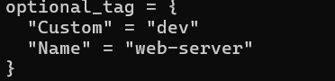
- Any type variable:
variable "dynamic_value" {
type = any
description = "A variable that can accept any data type"
default = null
}
output "value_received" {
value = var.dynamic_value
}
- Now test the dynamic (any) variable with different types. For each change, update terraform.tfvars with the specified value and run terraform apply -auto-approve, then capture the output.
a) String
In terraform.tfvars:
dynamic_value = "hello"
Run:
terraform apply -auto-approve
Save screenshot as: task6_dynamic_value_string.png — apply output when dynamic_value = "hello".
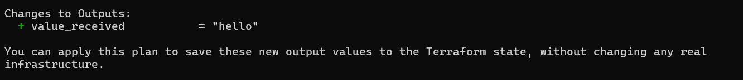
b) Number
Change terraform.tfvars:
dynamic_value = 42
Run:
terraform apply -auto-approve
Save screenshot as: task6_dynamic_value_number.png — apply output when dynamic_value = 42.
c) List
Change terraform.tfvars:
dynamic_value = ["a", "b", "c"]
Run:
terraform apply -auto-approve
Save screenshot as: task6_dynamic_value_list.png — apply output when dynamic_value is a list.
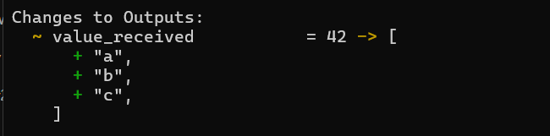
d) Map / Object
Change terraform.tfvars:
dynamic_value = {
name = "server"
cpu = 4
}
Run:
terraform apply -auto-approve
Save screenshot as: task6_dynamic_value_map.png — apply output when dynamic_value is a map/object.
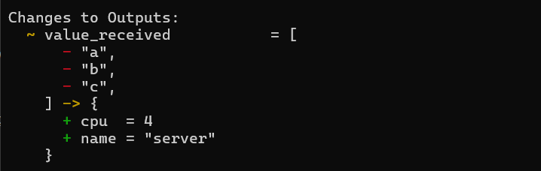
e) Null
Change terraform.tfvars:
dynamic_value = null
Run:
terraform apply -auto-approve
Save screenshot as: task6_dynamic_value_null.png — apply output when dynamic_value = null.
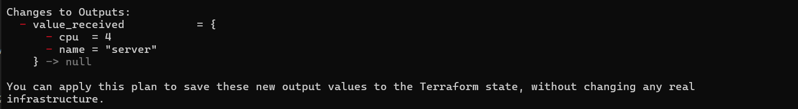

Task 7 — Git ignore

- Create .gitignore:
touch .gitignore
Add entries:
.terraform/*
*.tfstate
*.tfstate.*
*.tfvars
*.pem
Save screenshot as: task7_gitignore_created.png — .gitignore file content showing entries.
Note: This prevents secrets and state files from being accidentally committed.
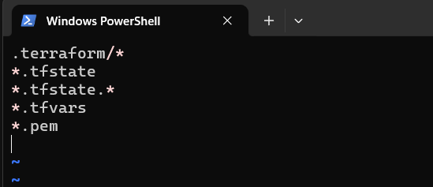

Task 8 — Clean-up then build real infra (VPC, Subnet, IGW, routing, default route table)
- Clean previous files
Remove all variable assignments from terraform.tfvars (empty the file or delete it).
Remove all content from locals.tf (delete or empty the file).
Replace main.tf contents with only the provider block below (start fresh).
Provider block to put in main.tf:
provider "aws" {
shared_config_files = ["~/.aws/config"]
shared_credentials_files = ["~/.aws/credentials"]
}
Save screenshot as: task8_clean_files.png — showing cleaned terraform.tfvars, locals.tf, and main.tf.
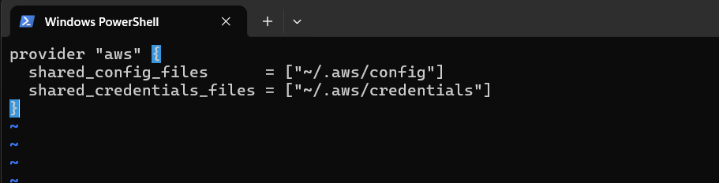
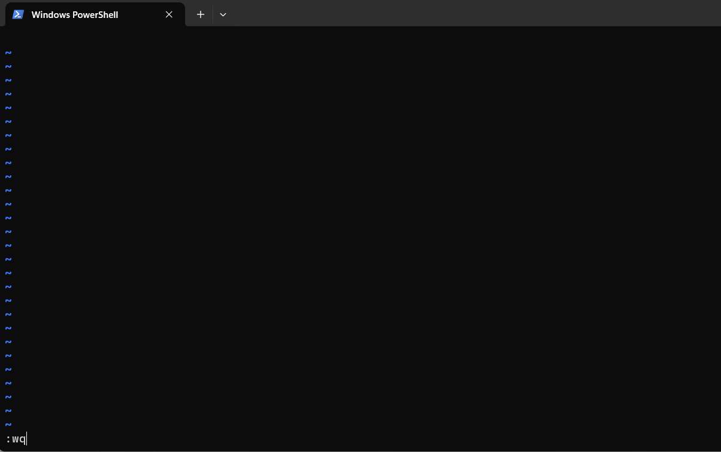
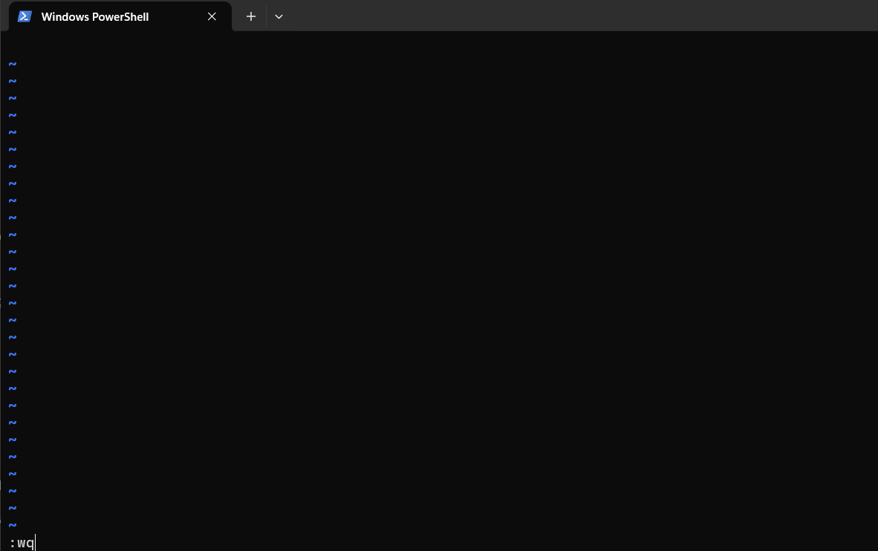

- Define variables in main.tf Add these variable declarations to main.tf (below the provider block):
variable "vpc_cidr_block" {}variable "subnet_cidr_block" {}variable "availability_zone" {}variable "env_prefix" {}
Save screenshot as: task8_variables_recreated.png — main.tf showing the four variables added.
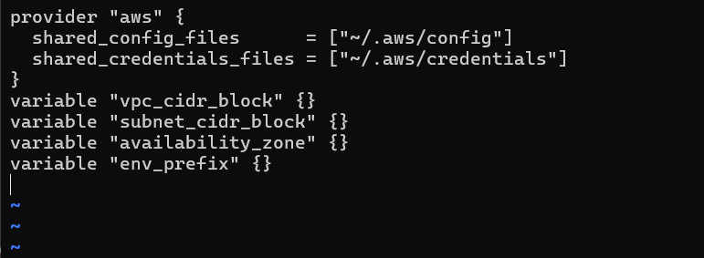
- Create VPC in main.tf Add the VPC resource to main.tf:
resource "aws_vpc" "myapp_vpc" {
cidr_block = var.vpc_cidr_block
tags = {
Name = "${var.env_prefix}-vpc"
}
}
Save screenshot as: task8_vpc_resources_added.png — main.tf showing aws_vpc resource (after adding VPC).
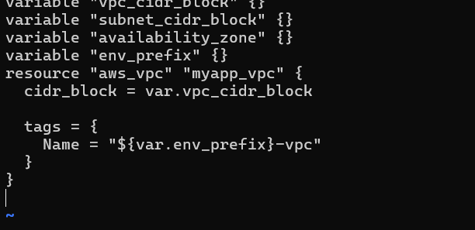
- Create Subnet in the VPC Add the subnet resource to main.tf:
resource "aws_subnet" "myapp_subnet_1" {
vpc_id = aws_vpc.myapp_vpc.id
cidr_block = var.subnet_cidr_block
availability_zone = var.availability_zone
tags = {
Name = "${var.env_prefix}-subnet-1"
}
}
Save screenshot as: task8_subnet_resources_added.png — main.tf showing aws_subnet resource (after adding subnet).
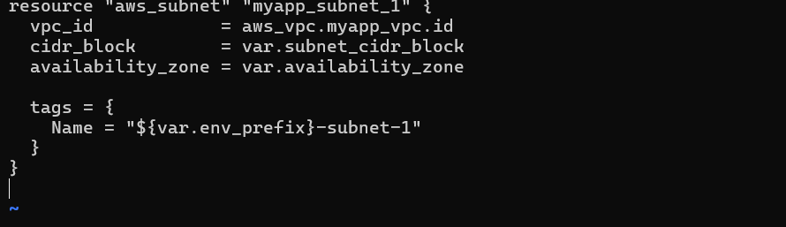
- Populate terraform.tfvars In terraform.tfvars add:
vpc_cidr_block = "10.0.0.0/16"subnet_cidr_block = "10.0.10.0/24"availability_zone = "me-central-1a"env_prefix = "dev"
Save screenshot as: task8_terraform_tfvars_vpc_values.png — terraform.tfvars content showing the values added.
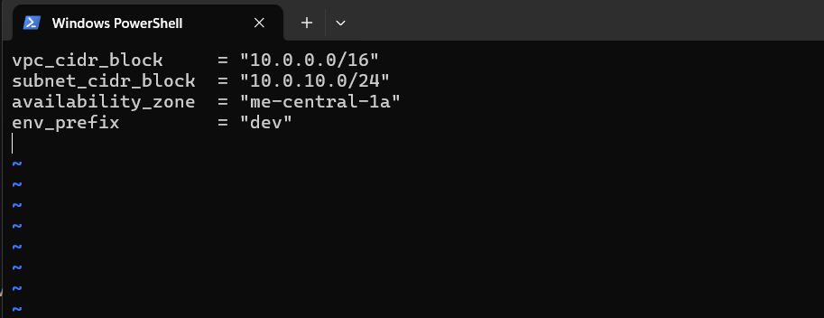
- Apply to create VPC and Subnet Initialize (if needed) and apply:
terraform init
terraform apply -auto-approve
Verify in AWS Console that the VPC and Subnet were created.
Save screenshot as: task8_vpc_subnet_apply.png — terraform apply output showing VPC and subnet creation on AWS console screenshot.
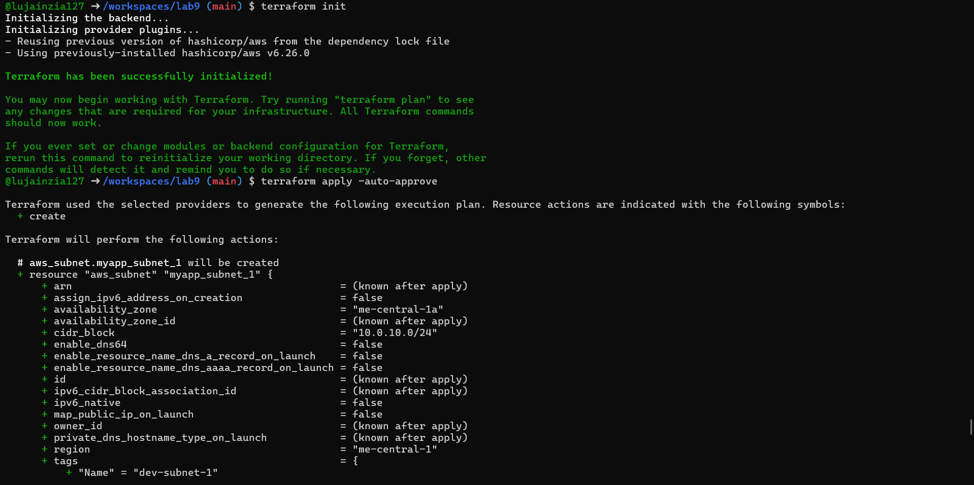
- Create Internet Gateway and Route Table (custom) Add the Internet Gateway and a custom Route Table to main.tf:
resource "aws_internet_gateway" "myapp_igw" {
vpc_id = aws_vpc.myapp_vpc.id
tags = {
Name = "${var.env_prefix}-igw"
}
}
resource "aws_route_table" "myapp_route_table" {
vpc_id = aws_vpc.myapp_vpc.id

route {
cidr_block = "0.0.0.0/0"
gateway_id = aws_internet_gateway.myapp_igw.id
}

tags = {
Name = "${var.env_prefix}-rt"
}
}
Save screenshot as: task8_igw_route_table_before_apply.png — AWS console showing IGW and route table resources (before apply).
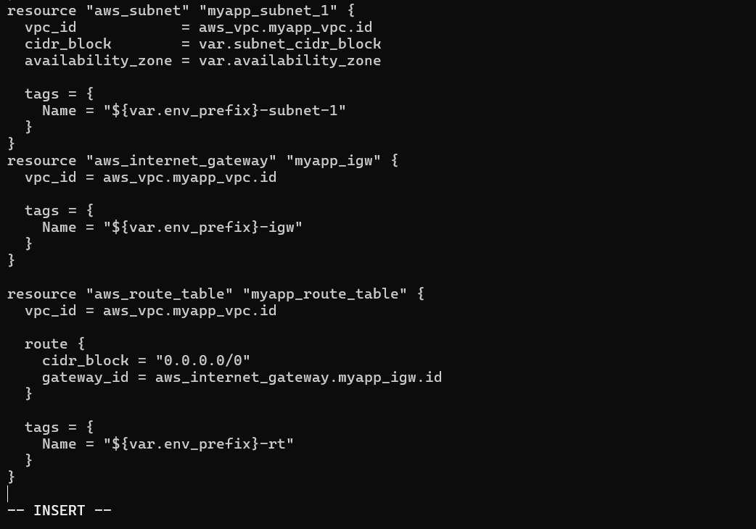
Apply:
terraform apply -auto-approve
Verify IGW and route table in AWS Console.
Save screenshot as: task8_igw_route_table_after_apply.png — terraform apply output showing IGW and route table creation on AWS console.
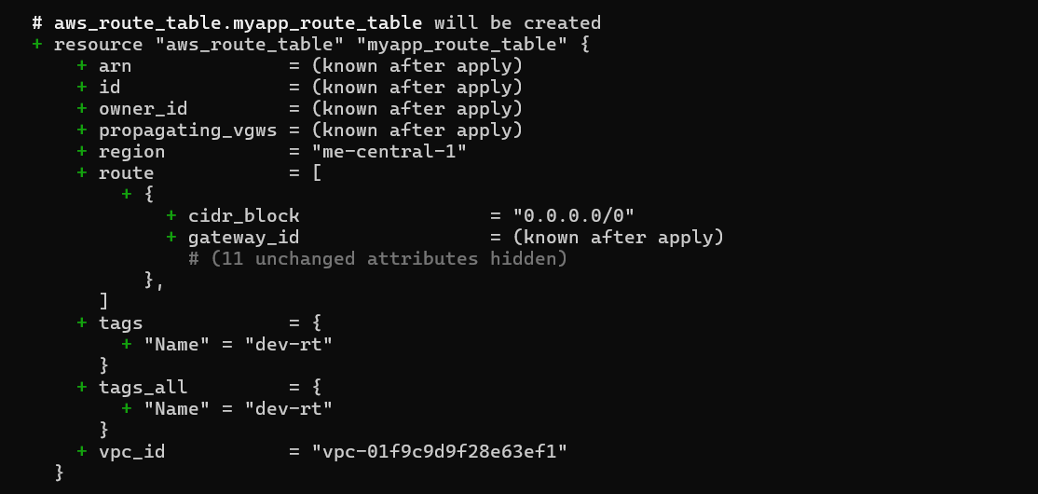
- Associate the Route Table with the Subnet Add the
association resource to main.tf:
resource "aws_route_table_association" "a_rtb_subnet" {
subnet_id = aws_subnet.myapp_subnet_1.id
route_table_id = aws_route_table.myapp_route_table.id
}
Apply:
terraform apply -auto-approve
Verify association in AWS Console (Subnet → Route Table).
Save screenshot as: task8_association_apply.png — terraform apply output showing association creation.
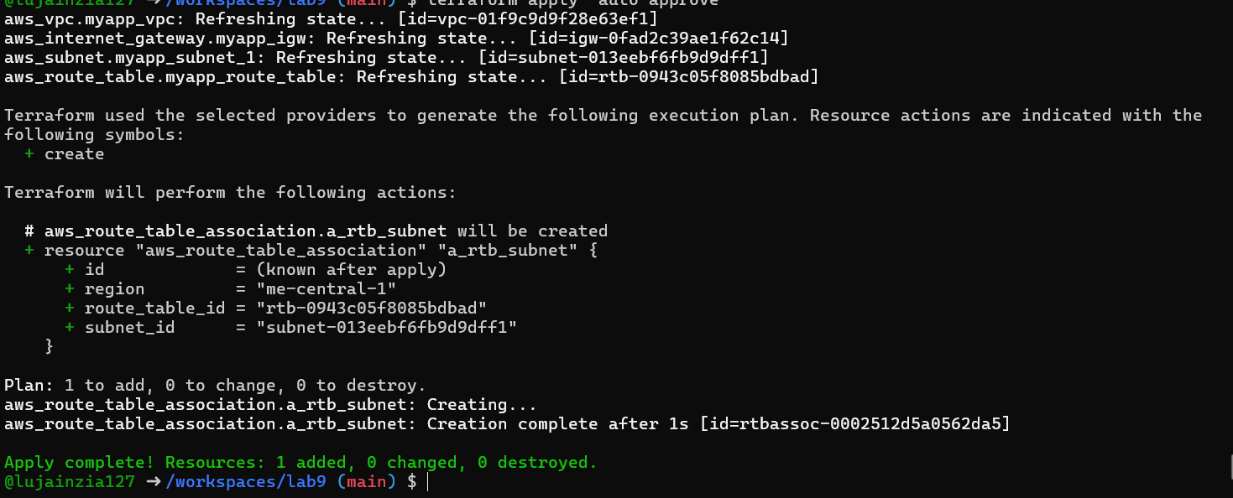
- Switch to default route table (use VPC default route table) Now remove (or comment out) the custom route table and association resources from main.tf:
Remove the aws_route_table "myapp_route_table" block.
Remove the aws_route_table_association "a_rtb_subnet" block.
Then add this resource to update the default route table with a route to the IGW:
resource "aws_default_route_table" "main_rt" {
default_route_table_id = aws_vpc.myapp_vpc.default_route_table_id

route {
cidr_block = "0.0.0.0/0"
gateway_id = aws_internet_gateway.myapp_igw.id
}

tags = {
Name = "${var.env_prefix}-rt"
}
}
Save screenshot as: task8_default_route_table.png — main.tf showing aws_default_route_table resource (after change).
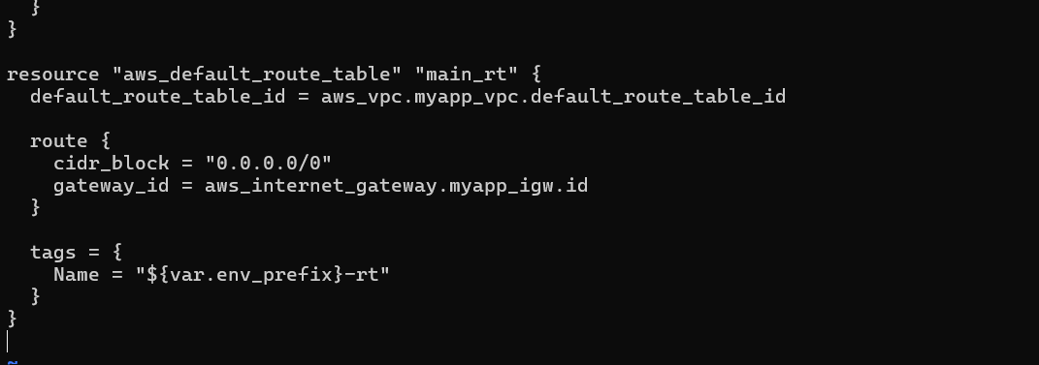
Apply:
terraform apply -auto-approve
Verify in AWS Console that the VPC's default route table has the 0.0.0.0/0 → IGW route and that the custom route table (if previously created) is no longer in use.
Save screenshot as: task8_default_route_table_apply.png — terraform apply output showing default route table update.
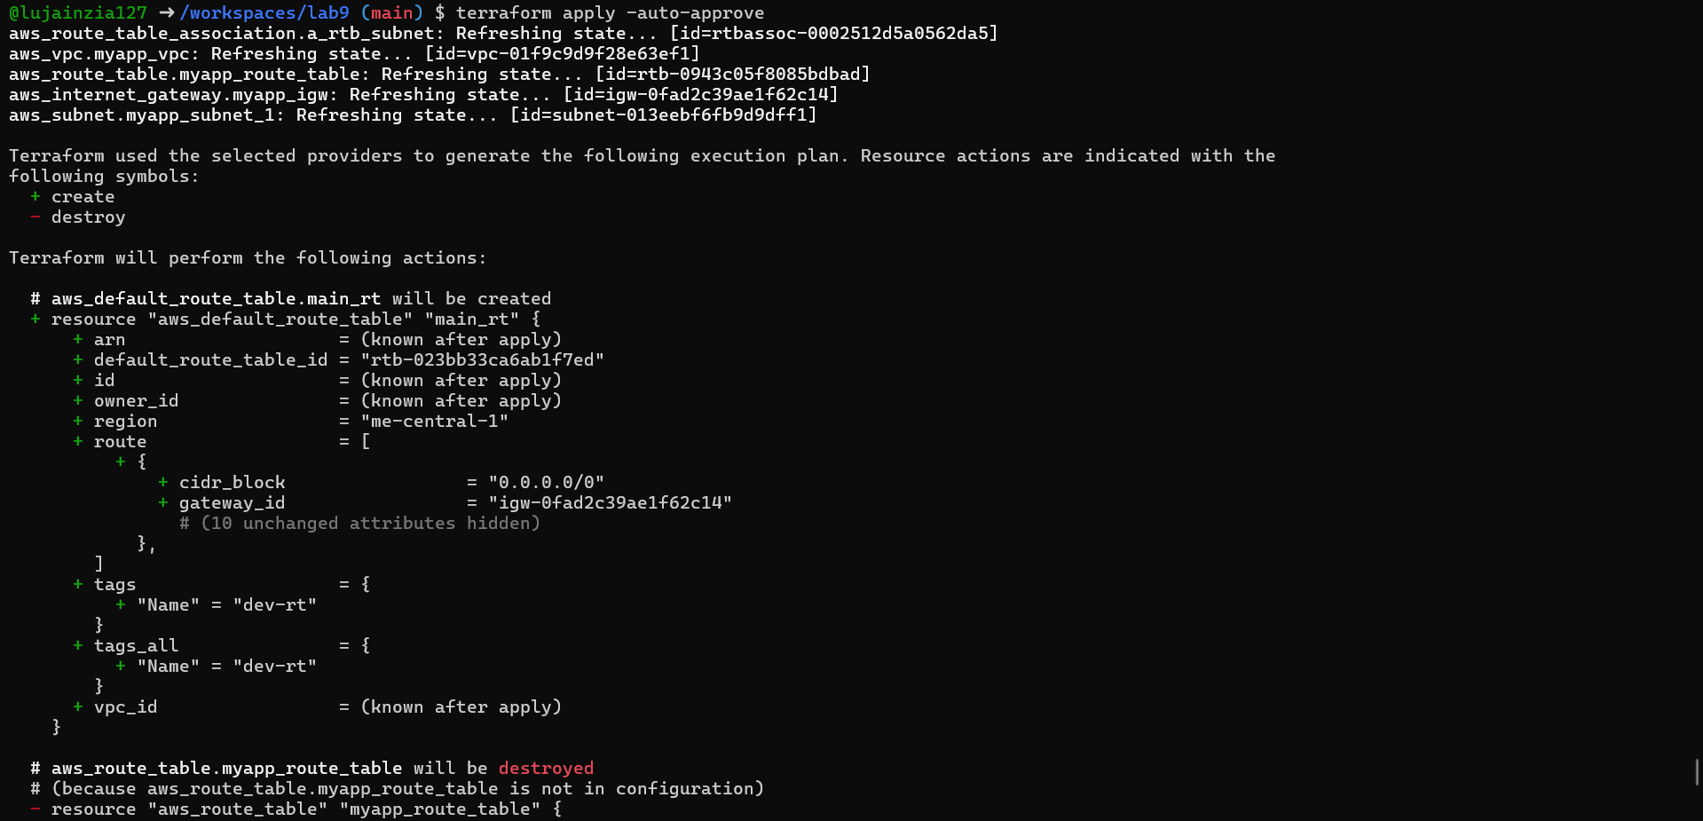

Task 9 — Security Group, Key Pair, EC2 Instance, user_data & nginx
- Add variables to main.tf Add these variables to your main.tf:
variable "my_ip" {}
Save screenshot as: task9_my_ip_variable_added.png — main.tf showing my_ip and other variables added.
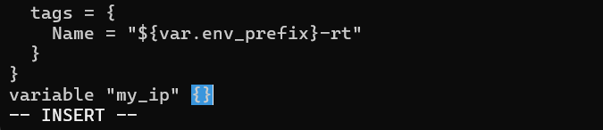
- Get your public IP and set terraform.tfvars From the Codespace shell:
curl icanhazip.com
Copy the IP and add to terraform.tfvars:
my_ip = "<your_ip>/32"instance_type = "t3.micro"availability_zone = "me-central-1a" # or your chosen AZenv_prefix = "dev"
Save screenshot as: task9_public_ip_curl.png — terminal showing curl icanhazip.com and terraform.tfvars edited with my_ip.
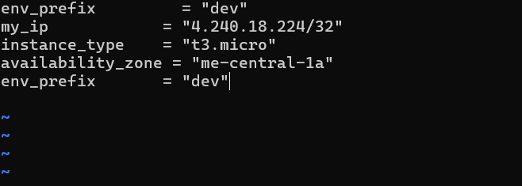

- Create the Security Group (main.tf) Add this resource to main.tf:
resource "aws_default_security_group" "myapp_sg" {
vpc_id = aws_vpc.myapp_vpc.id

ingress {
from_port = 22
to_port = 22
protocol = "tcp"
cidr_blocks = [var.my_ip]
}

ingress {
from_port = 80
to_port = 80
protocol = "tcp"
cidr_blocks = ["0.0.0.0/0"]
}

egress {
from_port = 0
to_port = 0
protocol = "-1"
cidr_blocks = ["0.0.0.0/0"]
prefix_list_ids = []
}

tags = {
Name = "${var.env_prefix}-sg"
}
}
Save screenshot as: task9_security_group_apply.png — main.tf showing security group resource (before apply).
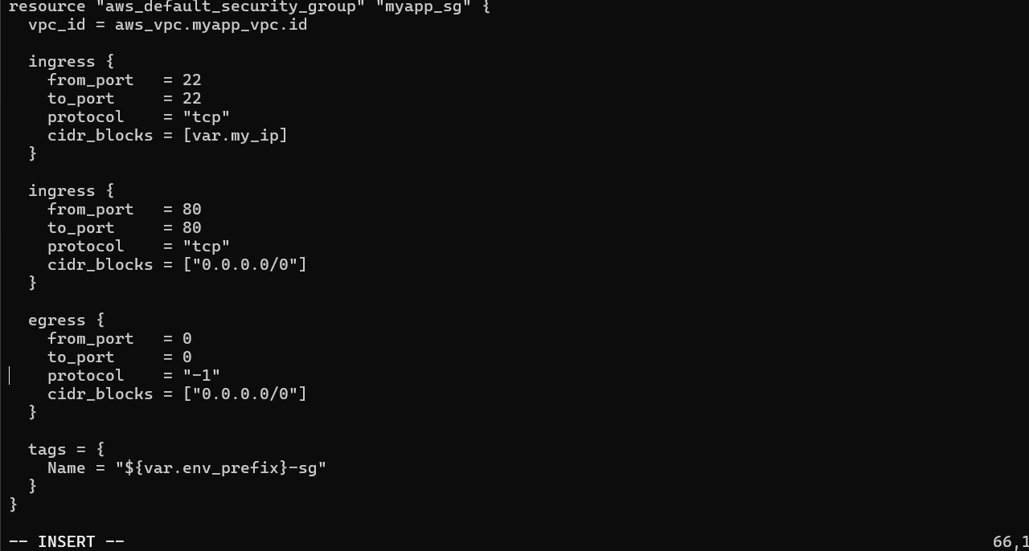
Run apply:
terraform apply -auto-approve
Save screenshot as: task9_security_group_apply.png — terminal showing terraform apply output for security group (after apply) and verify in AWS Console.
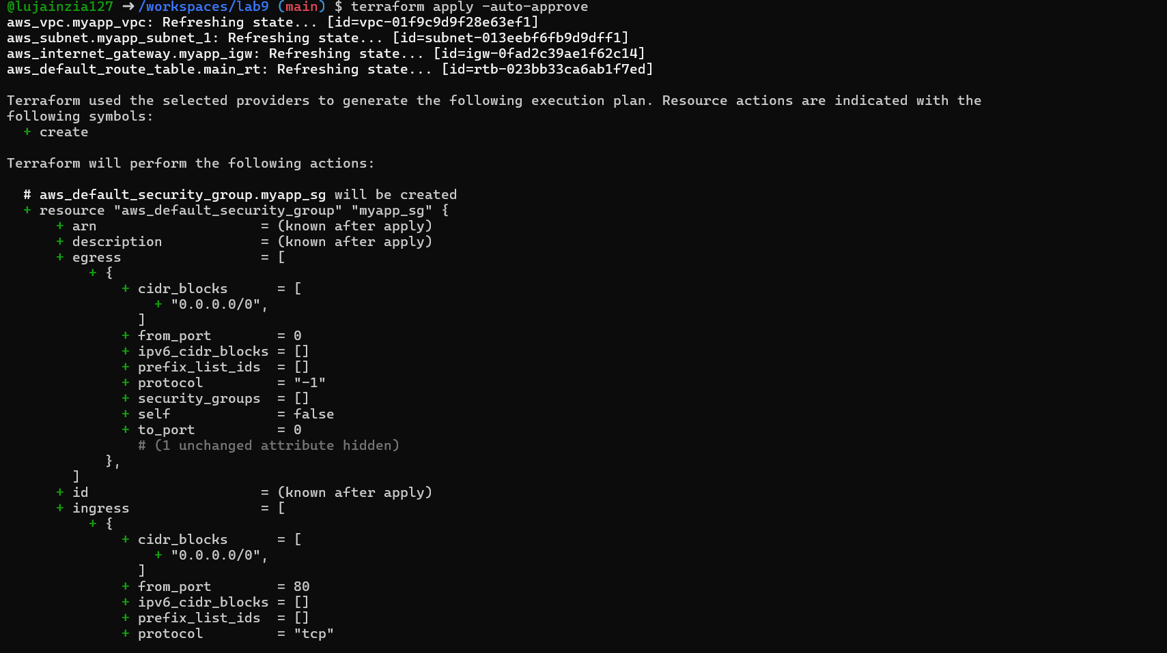
- Create an AWS key pair and save locally Create a key pair and store the private key in your Codespace. Do NOT commit the .pem file.
aws ec2 create-key-pair \
--key-name MyED25519Key \
--key-type ed25519 \
--key-format pem \
--query 'KeyMaterial' \
--output text > MyED25519Key.pem

chmod 600 MyED25519Key.pem
Save screenshot as: task9_keypair_created_and_saved.png — terminal showing key creation and MyED25519Key.pem saved.
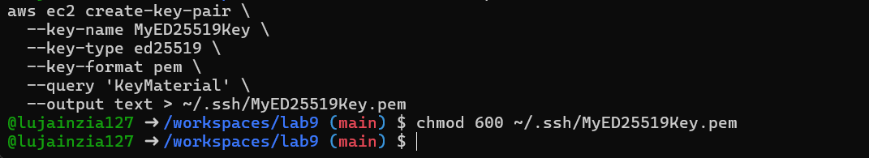
Ensure .gitignore contains:
*.pem
Save screenshot as: task9_keypair_created_and_saved.png — .gitignore showing *.pem entry.
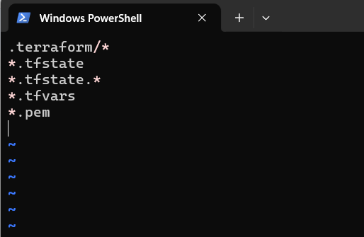
- Add EC2 instance resource (initial) Add the instance resource to main.tf (initially using the created key name):
resource "aws_instance" "myapp-server" {
ami = "ami-05524d6658fcf35b6" # Amazon Linux 2023
instance_type = var.instance_type
subnet_id = aws_subnet.myapp_subnet_1.id
security_groups = [aws_default_security_group.default_sg.id]
availability_zone = var.availability_zone
associate_public_ip_address = true
key_name = "MyED25519Key"

tags = {
Name = "${var.env_prefix}-ec2-instance"
}
}
output "aws_instance_public_ip" {
value = aws_instance.myapp-server.public_ip
}
Save screenshot as: task9_instance_type_set.png — main.tf showing instance_type variable and aws_instance resource (before apply).
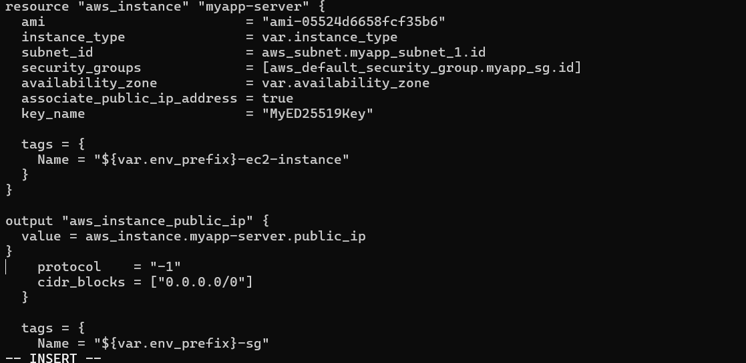
Run:
terraform apply -auto-approve
Save screenshot as: task9_ec2_apply_and_public_ip.png — terraform apply output showing EC2 created and public IP (or terraform output).
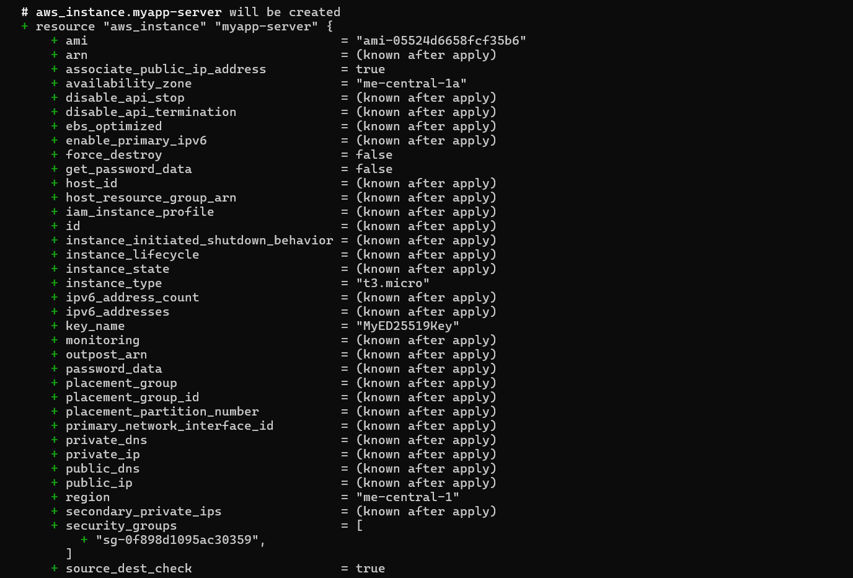
- SSH into the instance (using MyED25519Key) From the Codespace:
ssh -i MyED25519Key.pem ec2-user@<public-ip># verify commands, then exitexit
Save screenshot as: task9_ssh_into_ec2.png — terminal showing successful SSH session using MyED25519Key.pem.
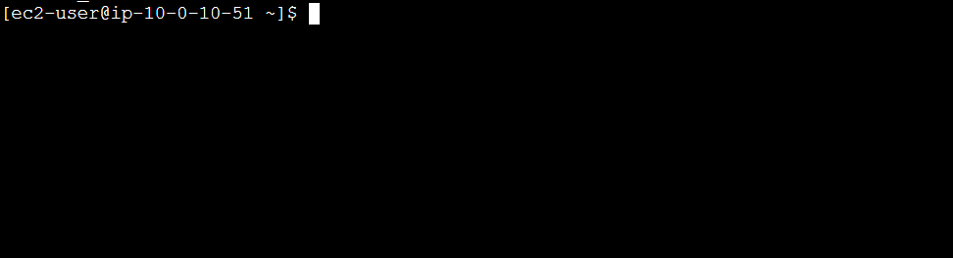
- Generate a local SSH keypair and register it in AWS via Terraform On your Codespace, generate an SSH key pair (accept defaults or specify path):
ssh-keygen -t ed25519 -f ~/.ssh/id_ed25519 -N ""
Save screenshot as: task9_ssh_keypair_and_ssh.png — terminal showing ssh-keygen output and files in ~/.ssh.
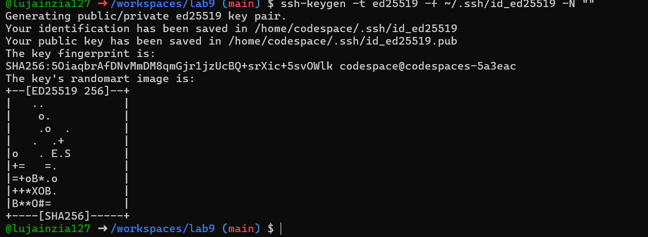
Add a Terraform resource in main.tf to register the public key:
resource "aws_key_pair" "ssh_key" {
key_name = "serverkey"
public_key = file("~/.ssh/id_ed25519.pub")
}
Update the EC2 resource to use the Terraform-managed key:
resource "aws_instance" "myapp-server" {
...# replace key_name = "MyED25519Key" with:key_name = aws_key_pair.ssh_key.key_name
...
}
Save screenshot as: task9_ssh_keypair_and_ssh.png — main.tf showing aws_key_pair resource and updated aws_instance key_name.
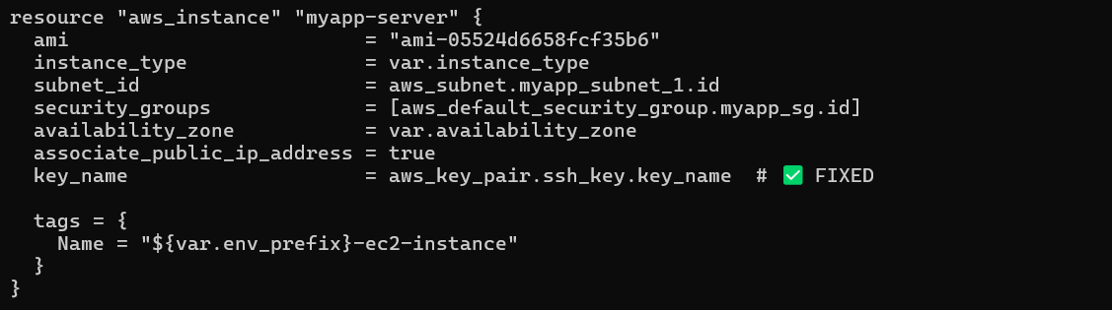
Run:
terraform apply -auto-approve
Save screenshot as: task9_ec2_apply_and_public_ip.png — terraform apply output showing EC2 updated to use new key (and any changes).
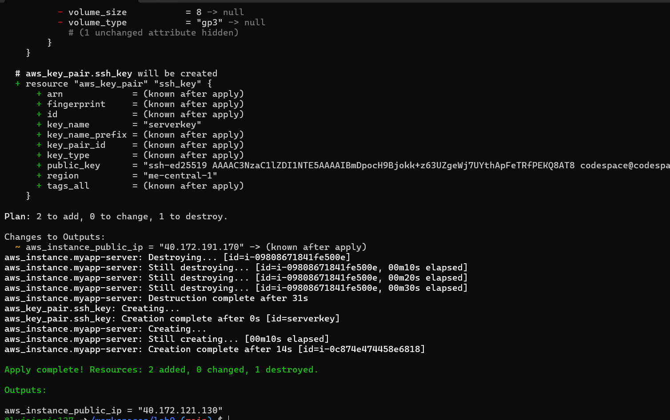
- SSH using the newly registered key Now SSH with your generated private key (the default ssh client will pick up ~/.ssh/id_ed25519):
ssh ec2-user@<public-ip>
Verify login works.
Save screenshot as: task9_ssh_keypair_and_ssh.png — terminal showing SSH session using the generated key.
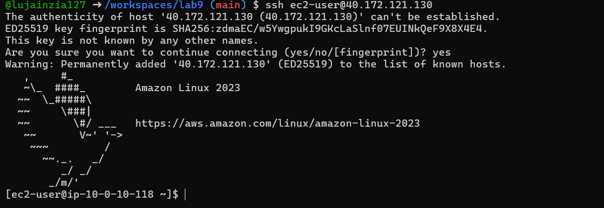
- Install nginx via inline user_data Modify the aws_instance resource to include inline user_data:
resource "aws_instance" "myapp-server" {
...user_data = <<EOF#!/bin/bashyum update -yyum install -y nginxsystemctl start nginxsystemctl enable nginxEOF
tags = {
Name = "${var.env_prefix}-ec2-instance"
}
}
Apply:
terraform apply -auto-approve
SSH in and run:
curl localhost
Open http://<public-ip> in a browser — you should see the nginx default page.
Save screenshot as: task9_nginx_local_curl.png — curl localhost inside the EC2 instance showing nginx response.
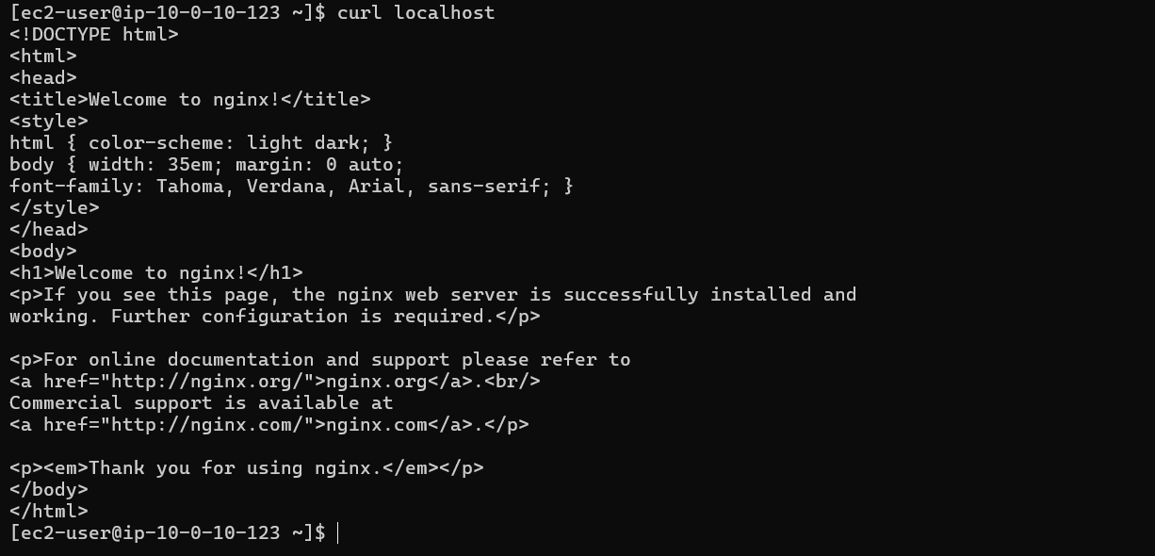
Save screenshot as: task9_nginx_browser_page.png — browser showing nginx default page at http://.
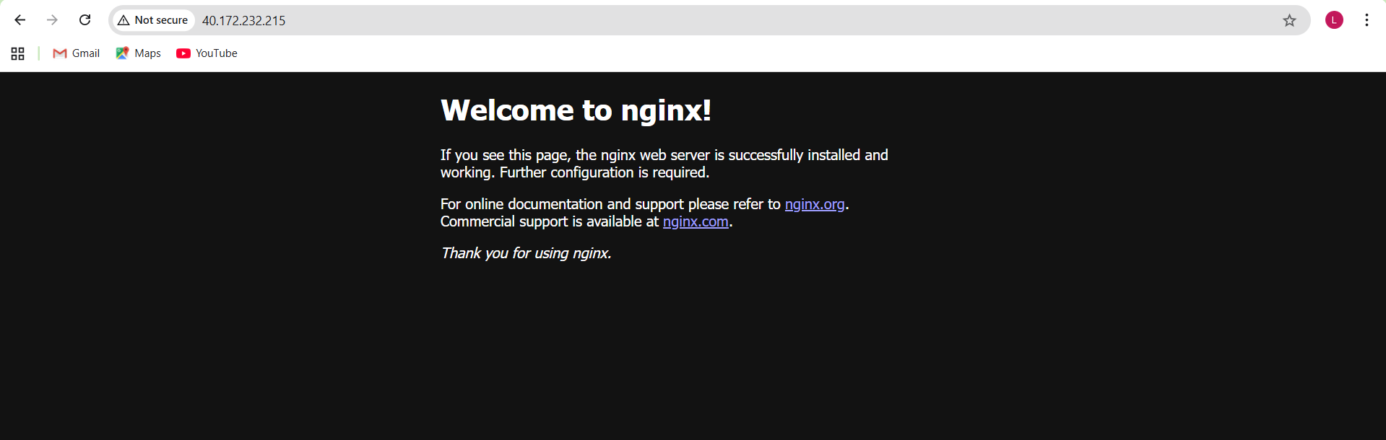
- Use an external script for user_data Create a script file in the Codespace:
cat > entry-script.sh <<'EOF'#!/bin/bashyum update -yyum install -y nginxsystemctl start nginxsystemctl enable nginxEOF
Save screenshot as: task9_nginx_local_curl.png — entry-script.sh created and permissions set.
Update aws_instance to use the file:
resource "aws_instance" "myapp-server" {
...user_data = file("entry-script.sh")
tags = {
Name = "${var.env_prefix}-ec2-instance"
}
}
Apply:
terraform apply -auto-approve
Reload the browser at http://<public-ip> to confirm nginx is served.
Save screenshot as: task9_nginx_browser_page.png — browser showing nginx page after using entry-script.sh.
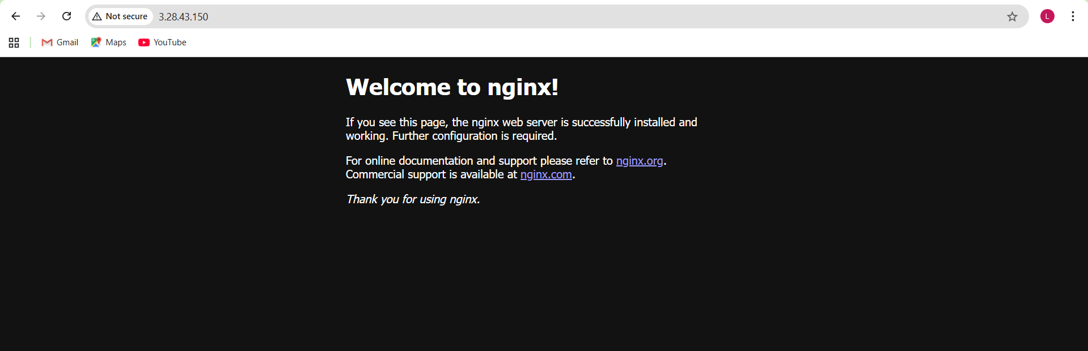
Cleanup

- Destroy all resources:
terraform destroy -auto-approve
Save screenshot as: cleanup_destroy.png — terraform destroy output showing resources deleted.
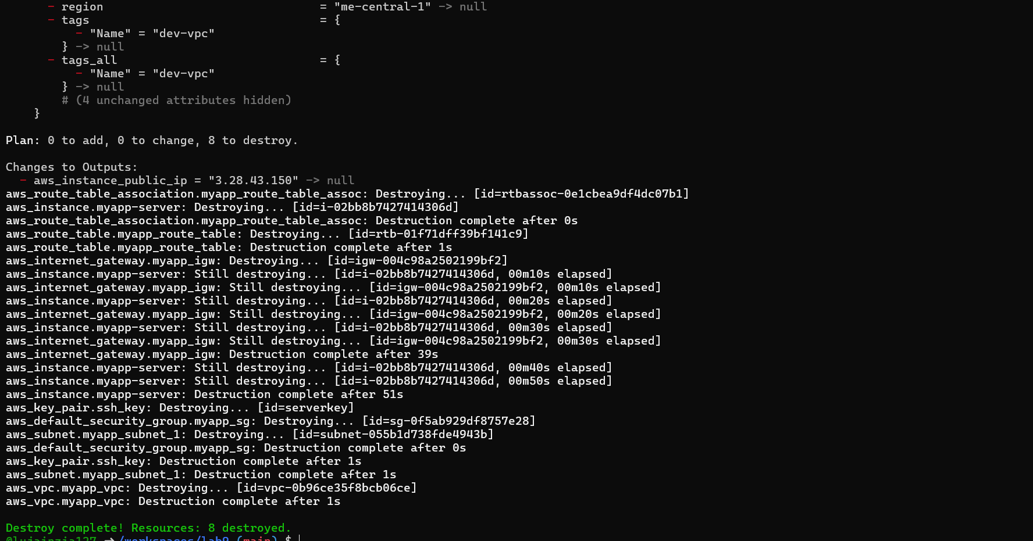
- Verify state files:
cat terraform.tfstate
cat terraform.tfstate.backup
Save screenshot as: cleanup_state_files.png — showing terraform.tfstate and terraform.tfstate.backup contents (ensure no secrets are exposed).
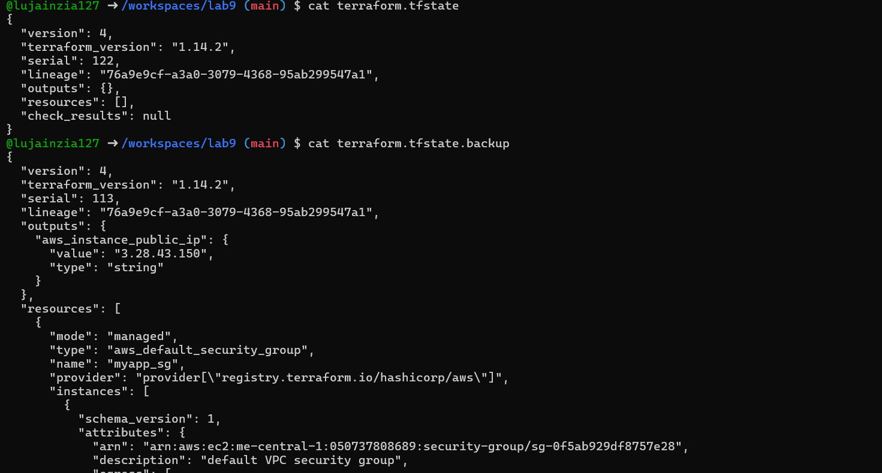
- Ensure no sensitive files are committed. If any private keys or credentials were accidentally committed — rotate them immediately.
Save screenshot as: cleanup_verify_no_secrets.png — git status and .gitignore confirming no .pem, .tfstate, or credentials are staged.
